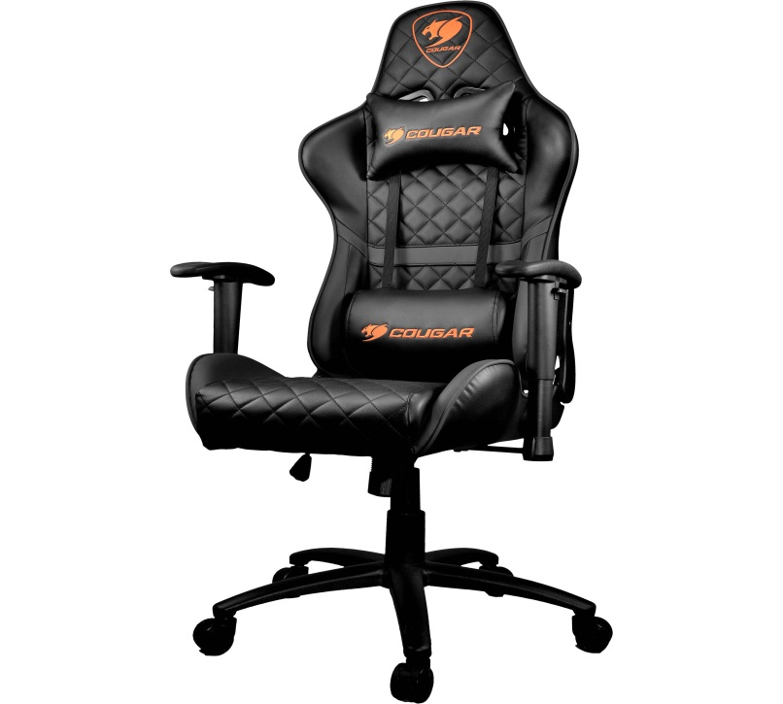

# Cougar Armor One Gaming Chair (Black Color.)

DISCRIPTION:

Diamond-Check Pattern Design  
High-Back Design  
Breathable PVC Leather  
180° Recline  
2D Adjustable Arm Rests  
Full Steel Frame  
Piston Lift Height Adjustment  
Class 4 Gas Lift Cylinder  
Head & Lumbar Pillows Included

